**PERSONAL REFLECTION**

Developing CineMatch, a Python based movie generator, was a significant turning point in my understanding of code literacy as both a technical and creative process. Having had no prior coding experience, I initially viewed coding as a rigid and inaccessible skill reserved for those with advanced technical knowledge. However, through experimentation, problem solving, peer collaboration and engagement with key readings, I developed confidence to approach it as analytical and communicative. This reflection explores key moments that shaped my development of code literacy and how these learnings will influence my future approach to digital media.

The first milestone of Cinematch involved downloading Visual Studio Code (VSC) and integrating Python language. Tutorials such as (Gray, 2023), helped me understand the coding environment including the terminal, debugging and file management which formed the foundation of my project. I then built a movie dataset in Google Docs for Netflix, Disney+, and Amazon, each with multiple genres and corresponding titles (Figure 1). During week 8, I implemented random.choice() following (HRK Tech, 2023) tutorial to enable console-based movie recommendations. Although the output was simple, it revealed how logical code translates into functional results, underscoring the importance of syntax errors such as misplaced brackets or inconsistent keys which caused major functionality issues. Guided by Silvia (2023), I refined my variable scoping, which enhanced my program understanding and cultivated foundational habits of patience. (Figure 2, 3)

In Week 9, my focus shifted towards enhancing user engagement through the development of a GUI. To achieve this, I implemented Python's Tkinter library following (ProgrammingKnowledge2, 2024), with the goal of allowing users to select streaming services and genres through dropdown menus and thus receive random movie recommendations. Initially, the installation of Tkinter within VSC proved challenging as I struggled to understand its functional framework. Peer collaborations with Ella, Alyssa and Karina, who were working on similar Python projects, were invaluable during this stage as we shared challenges with Tkinter integration. Despite these online resources and peer support, I encountered several technical issues in this stage. I misinterpreted layout parameters such as pady and found aligning widgets, handling logic, and debugging typo errors in output labels challenging (Figure 4, 5). Early validation and error handling mistakes caused confusion, but with guidance from online tutorials (GeeksforGeeks, 2020; GeeksforGeeks, 2023), I successfully built dropdown menus and output labels for movie recommendations. The moment a responsive interface appeared on screen was profoundly rewarding, demonstrating the tangible outcome of persistent iteration (Figure 6, 7, 8) .

The next stage drew on Norman's (2013) theory of affordances, which informed the creation of intuitive dropdown menus that guide users effortlessly through available options. Unlike backend logic which primarily relied on algorithmic thinking, GUI development required experimentation. Guided by Kuniavsky (2008), I learnt how usability and aesthetics shape user perception, prompting me not to “overload affordances” (p.1). Applying these insights, I customised Cinematch with a cinema inspired red colour scheme, enhancing visual coherence and reinforcing thematic engagement. This process fundamentally shifted my conception of programming from just making something work to thoughtfully crafting how the user experiences functionality. (Figure 9, 10)

The final and most complex stage of my project was adding a five-star rating system. My goal was to create star widgets that would update dynamically based on user input and store ratings for each recommended movie. Implementing this required loops and variable scope management. Initially, hover states failed to reset, ratings overlapped, and event bindings conflicted which disrupted the smooth functionality of the previous GUI functions. Debugging became a rigorous process, involving hours identifying why stars failed to reset correctly and why two Tkinter windows were opening (Figure 11, 12). This experience aligned with Ford's (2015) description of programming as ‘debugging one’s own thought process’. To address these issues, I followed several tutorials that guided me through star widget creation and event handling, including Stack overflow, programmingknowledge2 (2021) and CodeBasics (2020). Additionally, keeping a reflective journal during this stage proved invaluable. I tracked recurring errors, such as inconsistent variable names, misplaced indention and logical misalignment in my “if - else” statements. This reflective approach mirrored D. Berrys (2011) idea that code literacy involves recursive ‘self-correction’ (p.73) and ‘self-documentation’ (p.89). Peer collaboration also enhanced my interface clarity, as observing peers' approaches transformed confusion into insight, embodying what Striphas (2015) defines as the collaborative problem solving that mediates digital life and algorithmic culture. However, after persistent trial and error and lots of debugging, the star rating system and the past movies rated list finally worked seamlessly. Seeing the interactive stars respond correctly to user input was immensely satisfying and I felt a strong sense of accomplishment having overcome every challenge (Figure 13).

Looking back on this exposure subject, I can truly see how far I have progressed in both my technical understanding and confidence. This growth is clearly reflected in the evolution of my concept maps from Week 1 to Week 11. In Week 1, I felt as though I had been thrown into the deep end as depicted in my first concept map which was centered around the single idea of “algorithm", branching simply to “Memory”, “Variable”, and “Code” (Figure 14). This early attempt reflected my limited understanding and uncertainty towards coding concepts. By week 12, my concept map became more structured branching with “Operator” to “data type” and “Code” (Figure 15). This shift demonstrates not only my improved understanding of programming but also my ability to engage with unfamiliar and initially challenging material. Despite no prior experience, I proved I can adapt and develop competence beyond my initial interests.

However, while I was proud of my outcome, balancing the reflection, video and program with other assessments made it unrealistic to extend features, such as adding a pillow-based image module. Given the scale of my movie database this addition would have been time consuming. Nevertheless, this limitation highlighted the importance of setting achievable goals, something I misjudged in my initial A1 timeline. In hindsight, had I priorotised the GUI earlier rather than focusing on the basic console output in Weeks 7 and 8, this goal might have been attainable.

Developing CineMatch reshaped my perception of coding from a mechanical task to a reflective, creative practice. Each stage enabled me to develop the idea of computational thinking as a mindset that integrates logic, creativity and problem solving and which deepened my appreciation of code as a form of communication. Ultimately, Cinematch became a mirror of my coding journey, and this personal reflection marks not just the completion of my A2 but the development of a new way of thinking.

# **References**

Berry, D. M., & Proquest (Firm. (2011). *The philosophy of software code and mediation in the digital age*. Palgrave Macmillan.

Code 2020. (2020, October 10). *VS Code tips — Errors, warnings, and find results in the minimap*. YouTube. <https://www.youtube.com/watch?v=D3pEFnx5f7U>

Codemy. (2019a). *Dependent Drop Downs and List Boxes - Python Tkinter GUI Tutorial #152*. Www.youtube.com. <https://www.youtube.com/watch?v=bH9r3wM9Idw>

Codemy. (2019b, May 1). *Dropdown Menus With TKinter - Python Tkinter GUI Tutorial #18*. Www.youtube.com. <https://www.youtube.com/watch?v=3E_fK5hCUnI>

Codemy.com. (2020, April 21). *List Boxes - Python Tkinter GUI Tutorial #61*. YouTube. <https://www.youtube.com/watch?v=wEv3BworNK8>

Ford, P. (2015). *What Is Code? If You Don’t Know, You Need to Read This*. Bloomberg.com. <https://www.bloomberg.com/graphics/2015-paul-ford-what-is-code>

GeeksforGeeks. (2020, November 24). *Dropdown Menus in Tkinter*. GeeksforGeeks. <https://www.geeksforgeeks.org/python/dropdown-menus-tkinter/>

GeeksforGeeks. (2021, July 18). *Recommendation System in Python*. GeeksforGeeks. <https://www.geeksforgeeks.org/machine-learning/recommendation-system-in-python/>

GeeksforGeeks. (2023, July 19). *Tkinter Cheat Sheet*. GeeksforGeeks. <https://www.geeksforgeeks.org/python/tkinter-cheat-sheet/>

GeeksforGeeks. (2024, May 27). *Python Tkinter Mainloop*. GeeksforGeeks. <https://www.geeksforgeeks.org/python/python-tkinter-mainloop/>

Gray, D. (2023, February 15). *Python Tutorial for Beginners with VS Code 🐍*. Www.youtube.com. <https://www.youtube.com/watch?v=6i3e-j3wSf0>

HRK Tech. (2023, January 8). *How To install Any Python Module in Your VsCode (numpy,random,panda…...)*. YouTube. <https://www.youtube.com/watch?v=DR6wpDVsUsw>

JimShapedCoding. (2020, September 6). *Python GUI Development Tutorial - Introduction to TKinter | Create a random music player program*. YouTube. <https://www.youtube.com/watch?v=0tqZ6rMcqGE>

Kuniavsky, M. (2008). FEATUREUser experience design for ubiquitous computing. *Interactions*, *15*(6), 20–22. <https://doi.org/10.1145/1409040.1409045>

Mittelstadt, B. D., Allo, P., Taddeo, M., Wachter, S., & Floridi, L. (2016). The Ethics of algorithms: Mapping the Debate. *Big Data & Society*, *3*(2), 1–21. <https://doi.org/10.1177/2053951716679679>

Norman, D. (2013). *The Design of Everyday Things : Revised and Expanded Edition*. Basic Books. <https://dl.icdst.org/pdfs/files4/4bb8d08a9b309df7d86e62ec4056ceef.pdf>

ProgrammingKnowledge2. (2024, April 3). *How to Install Tkinter in Visual Studio Code on Windows 10 / 11*. YouTube. <https://www.youtube.com/watch?v=b64GU6kMTuI>

pyth. (2022, May 28). *Python Tkinter finding the average of star rating user button click*. Stack Overflow. <https://stackoverflow.com/questions/72415334/python-tkinter-finding-the-average-of-star-rating-user-button-click>

*Reddit - The heart of the internet*. (2020). Reddit.com. <https://www.reddit.com/r/madeinpython/comments/ia5rbv/movietv_showsdocumentary_recommendation_system/>

Ryan Noonan. (2020, February 13). *Python Tkinter GUI Widgets*. YouTube. <https://www.youtube.com/watch?v=3UVjr8Onll8>

S.M.D.S. (2023, December 4). *Learn How To Build RECOMMENDER SYSTEM with Python (TOO EASY!!!)*. YouTube. <https://www.youtube.com/watch?v=9ybv7TQtQ-M>

Silva, K. D. (2023, June 29). *OOP Concepts: Mastering Basics with Real-Life Examples for Easy Understanding.* Medium. <https://medium.com/@kalanamalshan98/oop-concepts-mastering-basics-with-real-life-examples-for-easy-understanding-part-1-da5b8fc21036>

Striphas, T. (2015). Algorithmic culture. *European Journal of Cultural Studies*, *18*(4-5), 395–412. <https://journals.sagepub.com/doi/10.1177/1367549415577392>

Tkinter․com. (2022, September 21). *How To Create Custom Widget Styles - Tkinter Projects 5*. YouTube. <https://www.youtube.com/watch?v=hoiMu6wto1c>

Tkinter․com. (2024, March 21). *Create Custom Widgets and Components! - Object Oriented Tkinter 6*. YouTube. <https://www.youtube.com/watch?v=CVIsMU7wVjI>

**APPENDIX:**

‘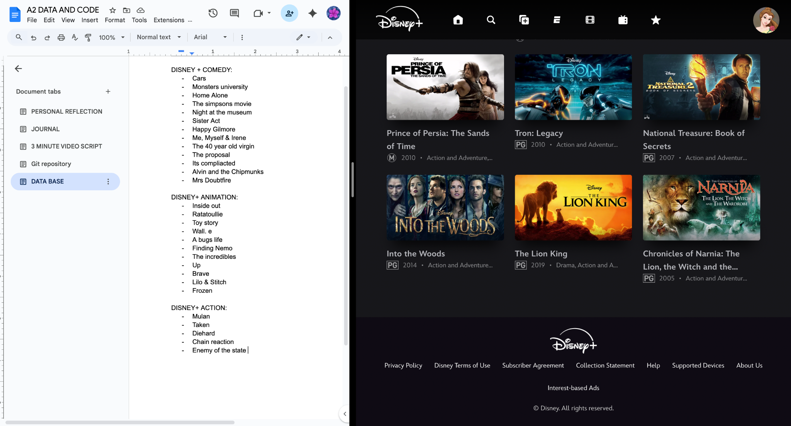

(Figure 1)

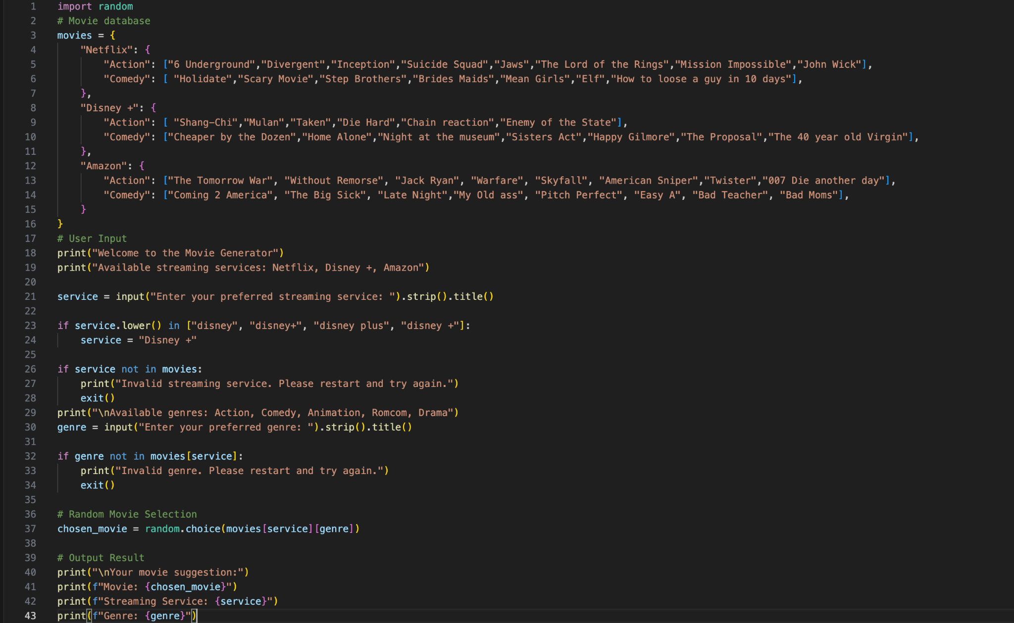 (Figure 2)

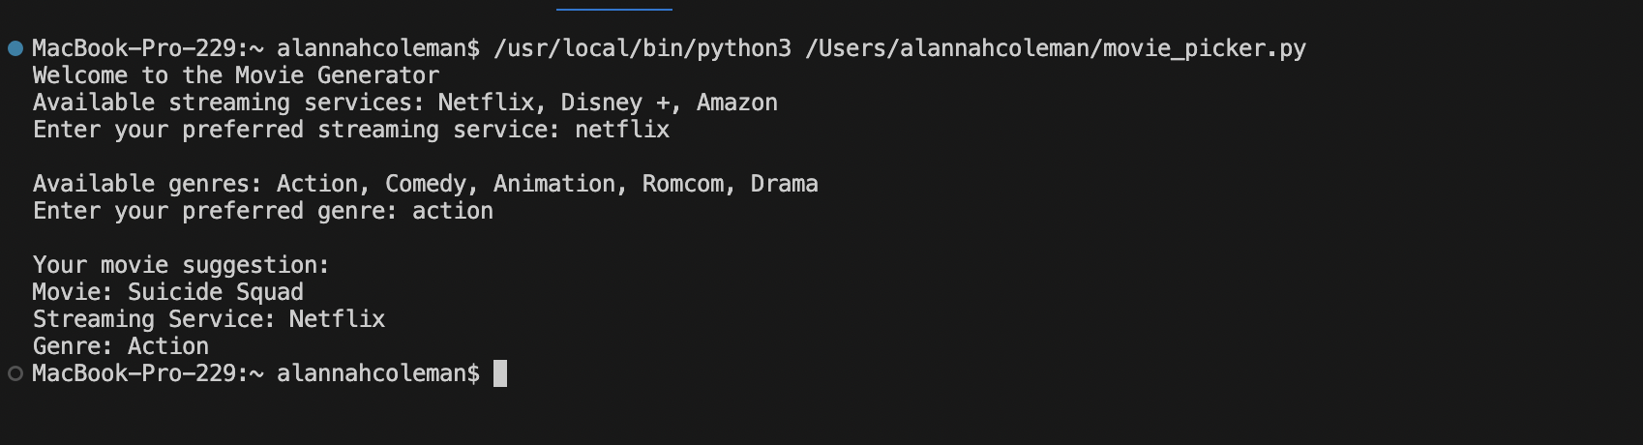(Figure 3)

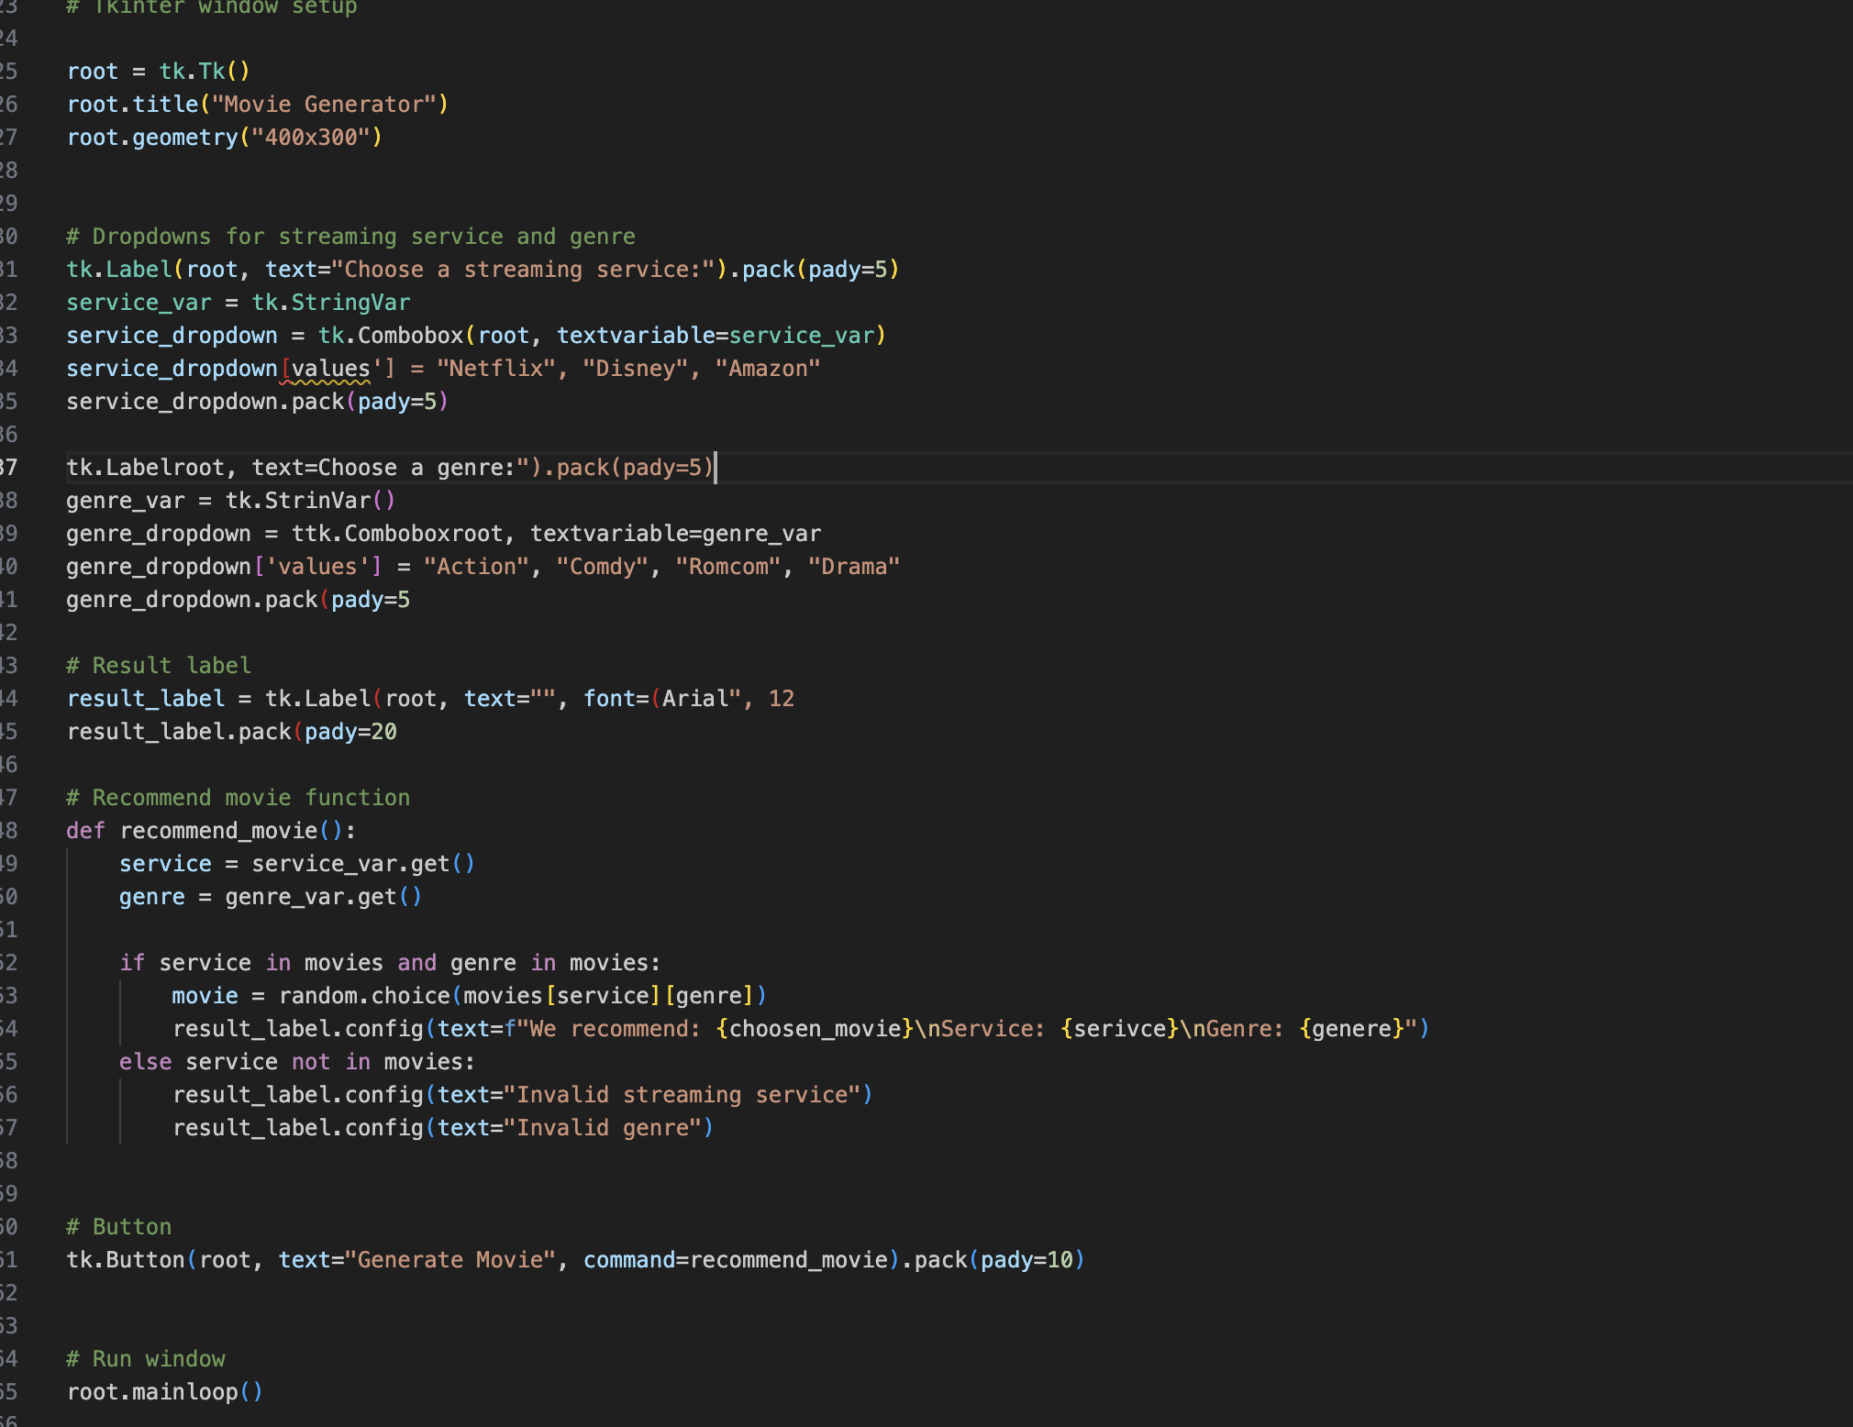(Figure 4)

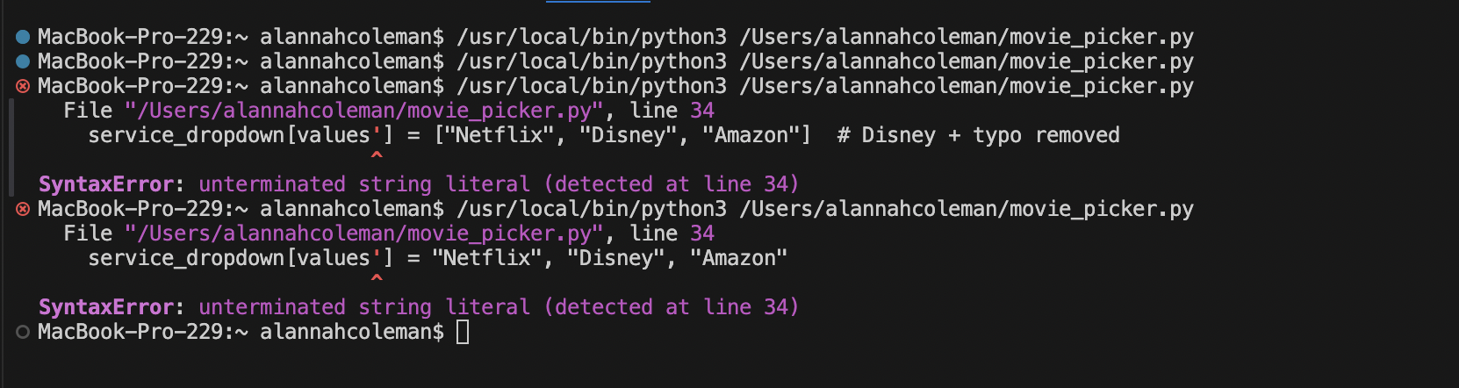(Figure 5)

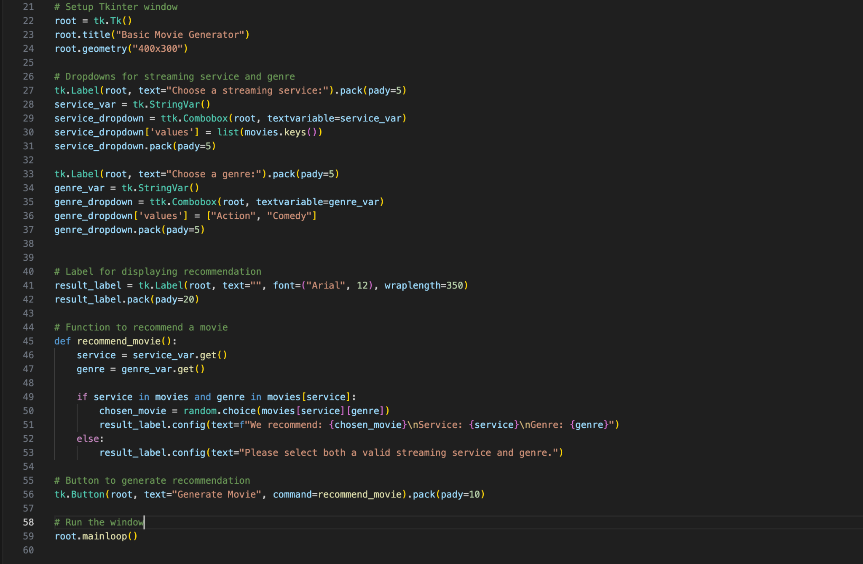(Figure 6)

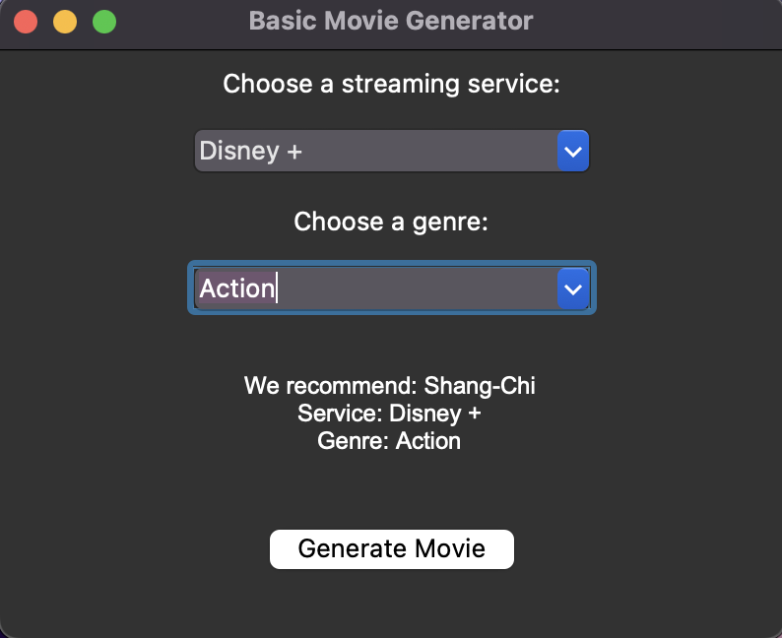

(Figure 7)

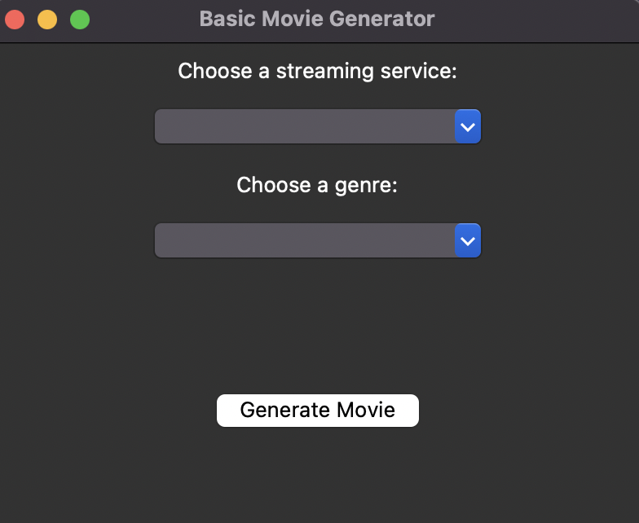

(Figure 8)

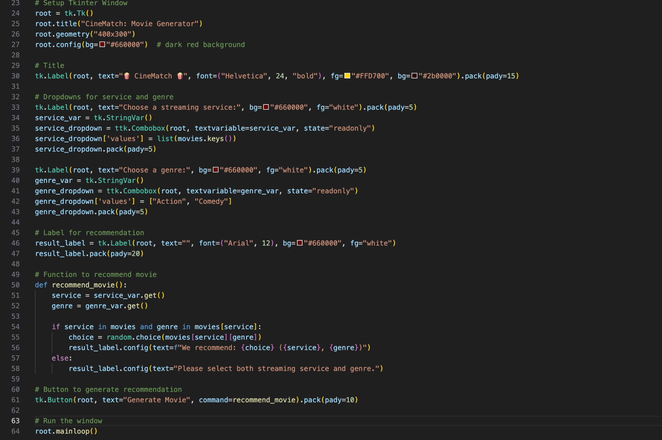

(Figure 9)

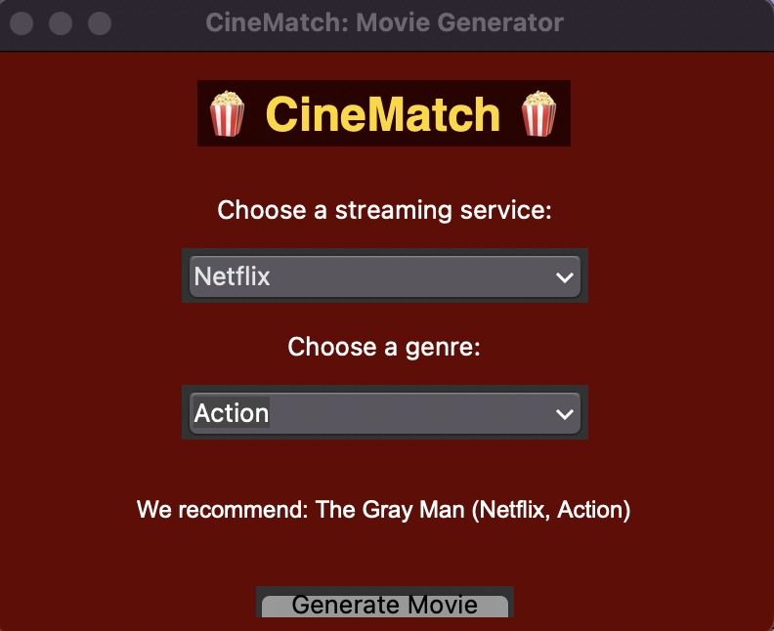

(Figure 10)

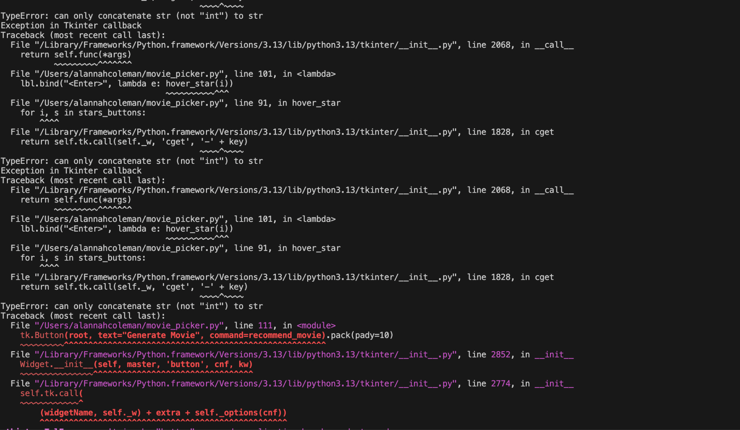

(Figure 11)

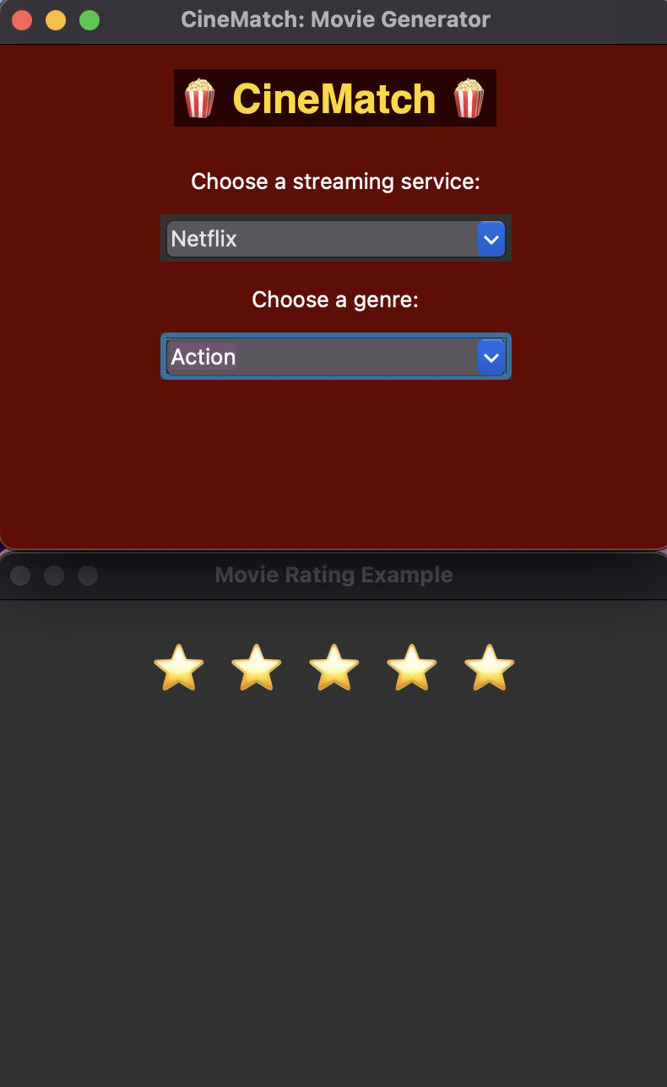

(Figure 12)

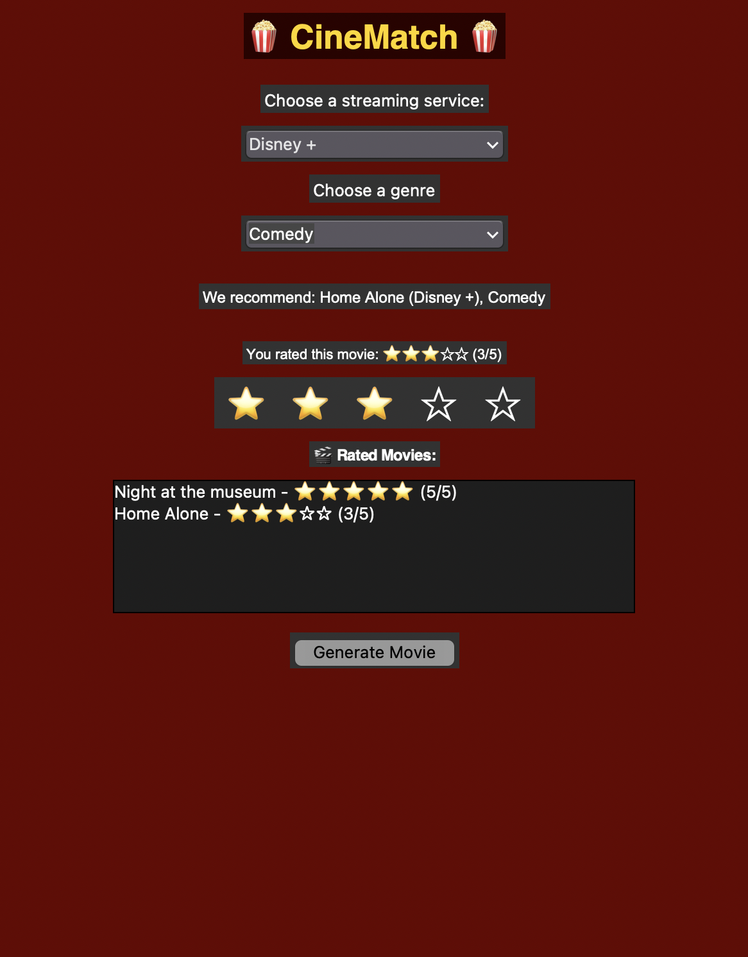

(Figure 13)

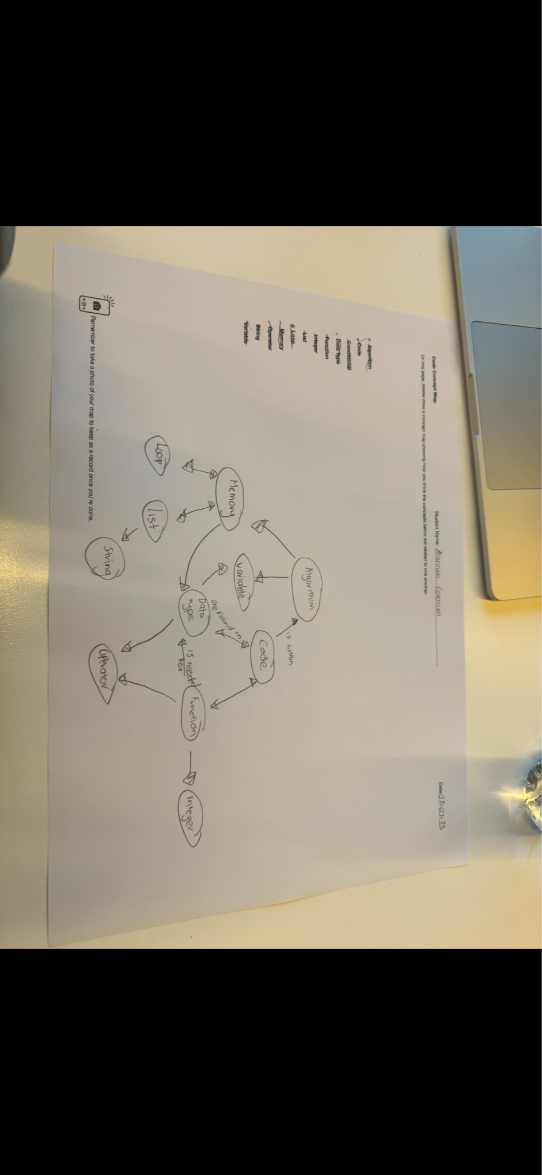

(Figure 14)

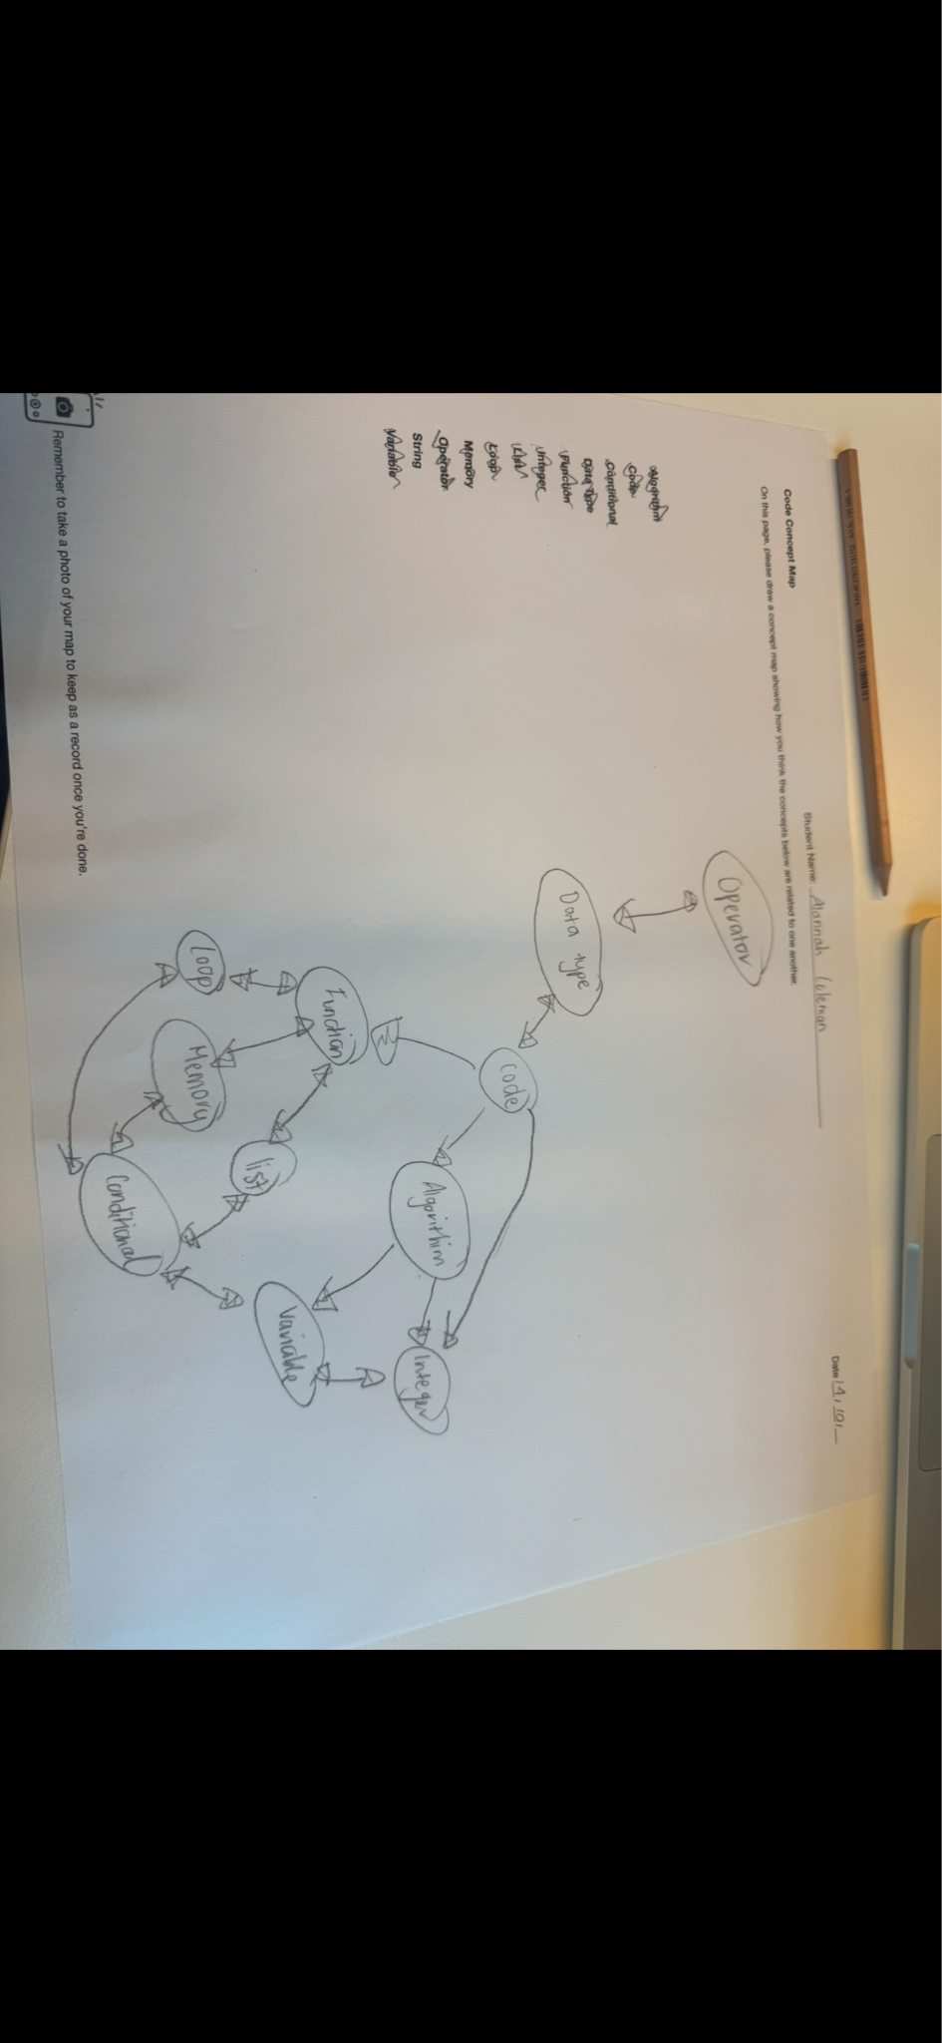

(Figure 15)

